Take-home assessment

(Time box: 1 day of work but submission within a week)

## Scenario:

An application team has tasked you to build a generic Web UI component that works like a Select/option native HTML element. Unfortunately, the native HTML select element does not support icons. So there is a need to build this as a React Web component to support this use case.

## Specs:

* Text for each option does not wrap
* Options can be disabled
* Selected option is highlighted
* There is always a default option, by default the first option is the default selected option
* Style it as close to the screen cap as possible

## Things to consider when building this component:

* Build it as a project using create-react-app project to showcase the component.
* Since we want to optimize this component, we do not want to use any third-party dependencies or wrapping other drop-down components.

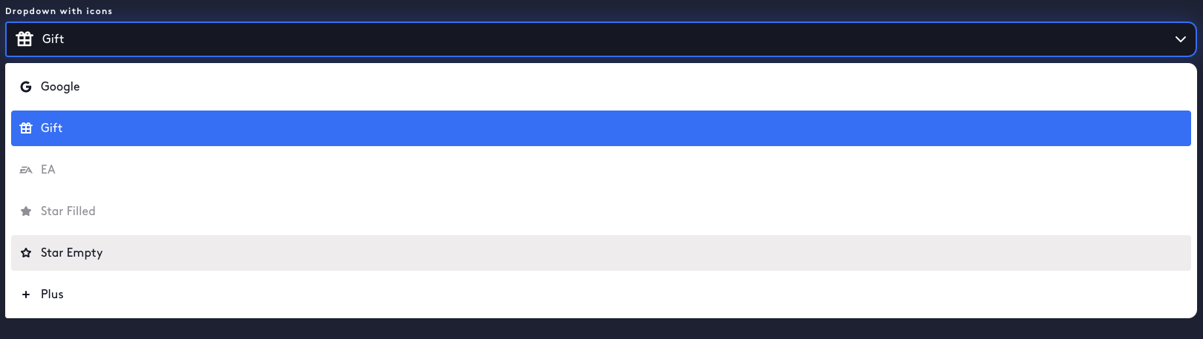

## How to deliver it:

* Delivered as a local git repo (zip file) or using an online code editor such as codepen